TOPIC 1-INTRODUCTION
1.
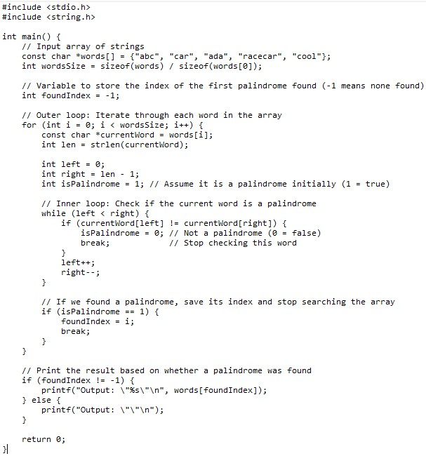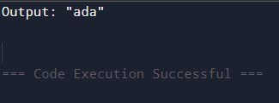
Time complexity: O(N * M)- worst case, O(M)- Best case.
Space Complexity: O(1)

2.
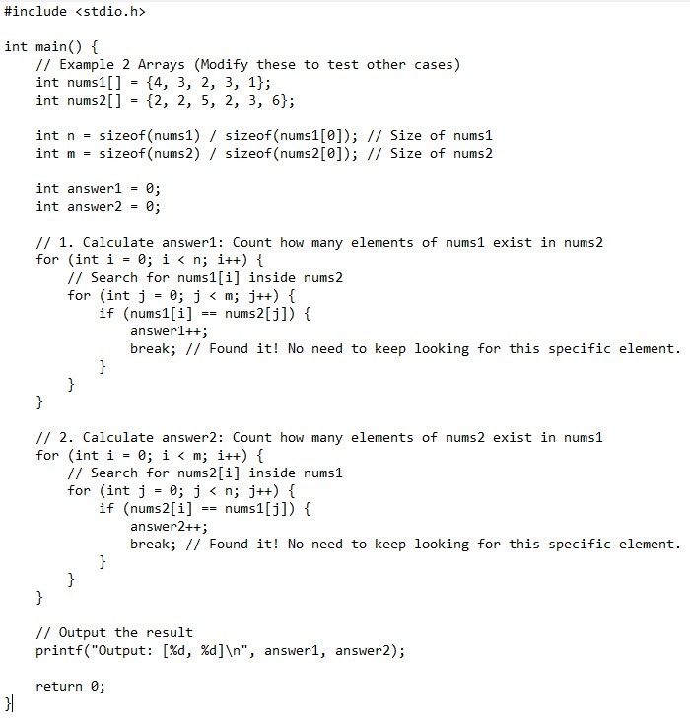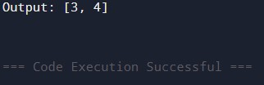
Time complexity: O(n*m)- Worst case, O(n+m)- Best case
Space complexity: O(1)

3.
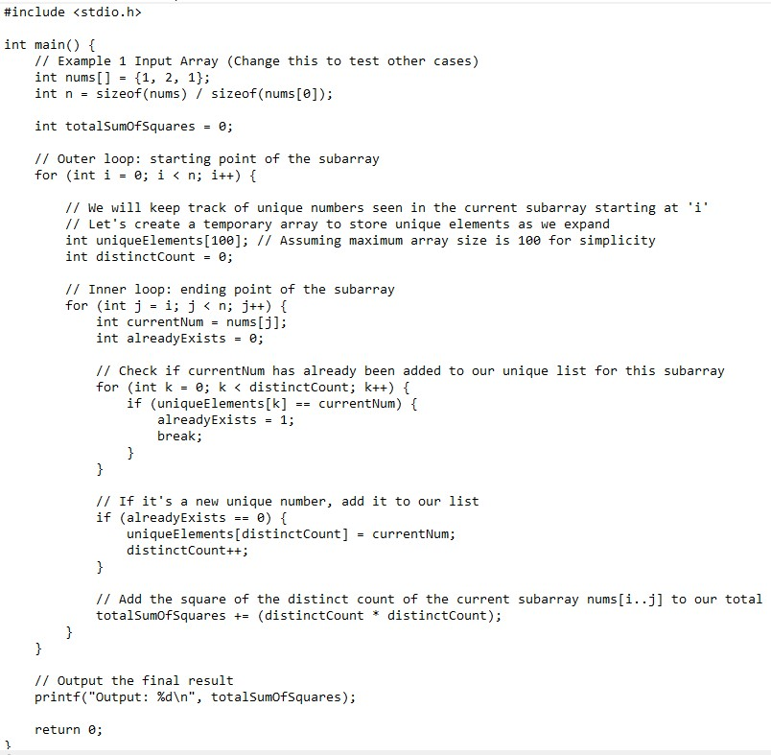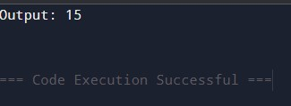
Time complexity: O(n^2)
Space Complexity: O(1)

4.
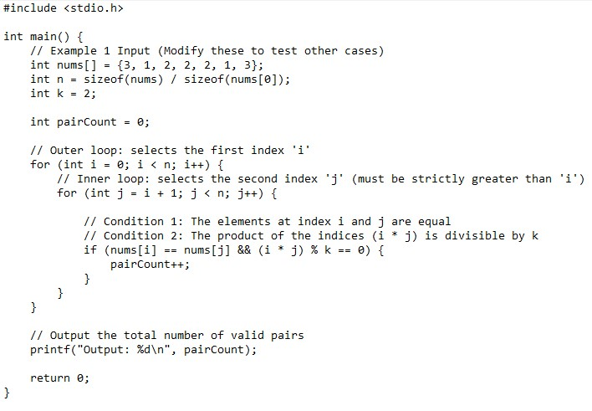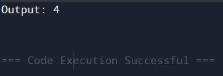
Time complexity: O(n^2)
Space complexity: O(1)

5.
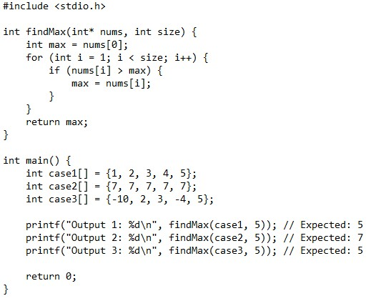
Output:
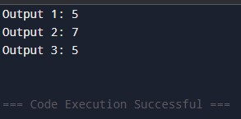

Time Complexity: O(n)
Space Complexity: O(1)

6
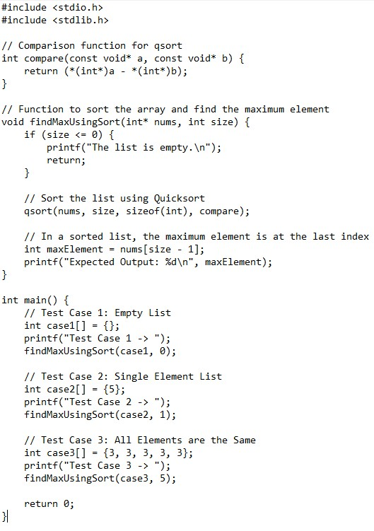
Output:
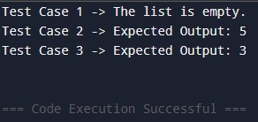
Time Complexity: O(n log n)
Space Complexity: O(log n)

7.
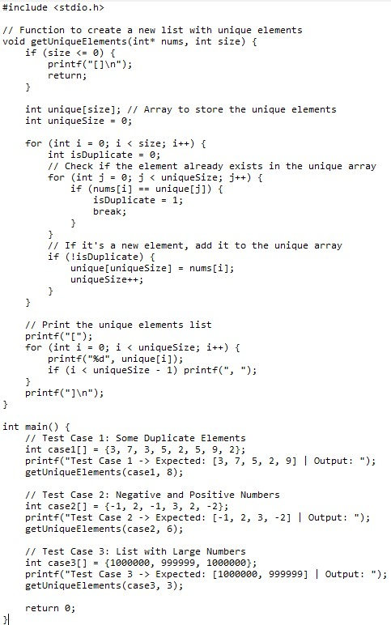
Output:
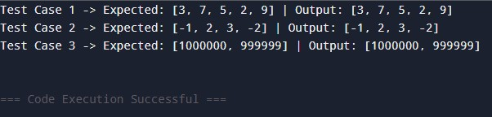
Time Complexity: O(n^2)
Space Complexity: O(n)

8.
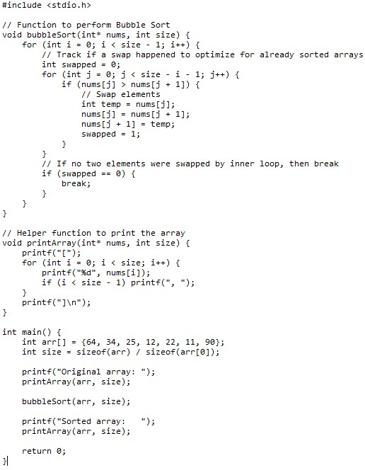
Output:
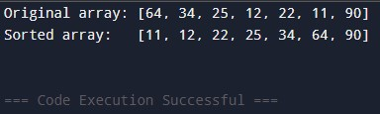
Time Complexity: O(n^2)
Space Complexity: O(1)

9.
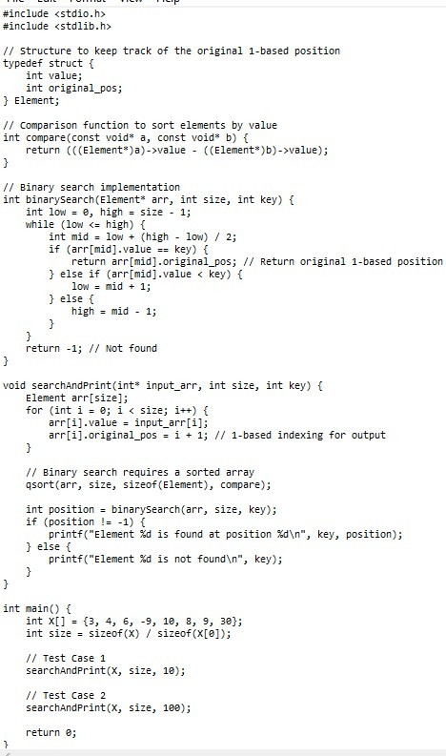
Output:
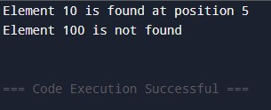
Time Complexity: O(log n)
Space Complexity: O(n)

10.
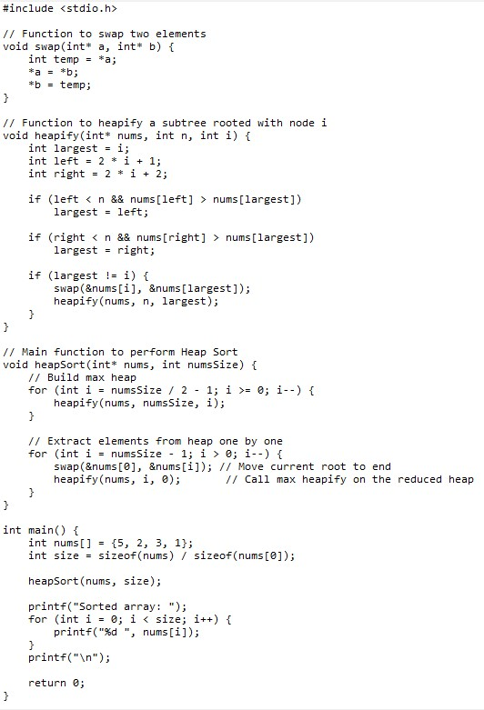
Output:
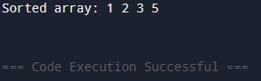
Time Complexity: O(n log n)
Space Complexity: O(1)

11.
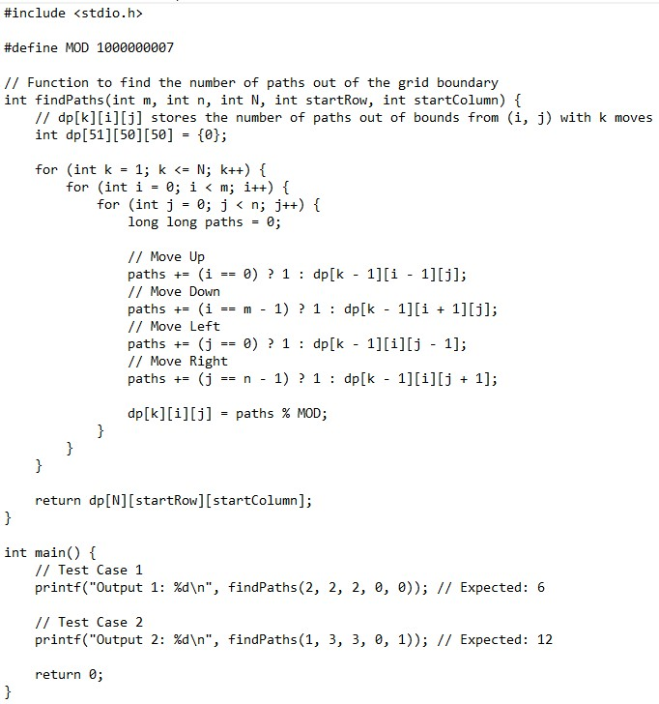
Output:
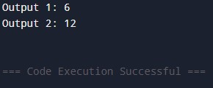
Time Complexity: O(N . m . n)
Space Complexity: O(N . m . n)

12.
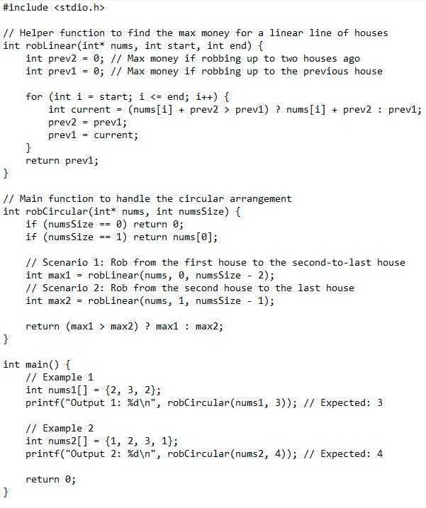
Output:
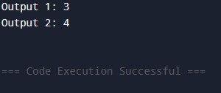
Time Complexity: O(n)
Space Complexity: O(1)

13.
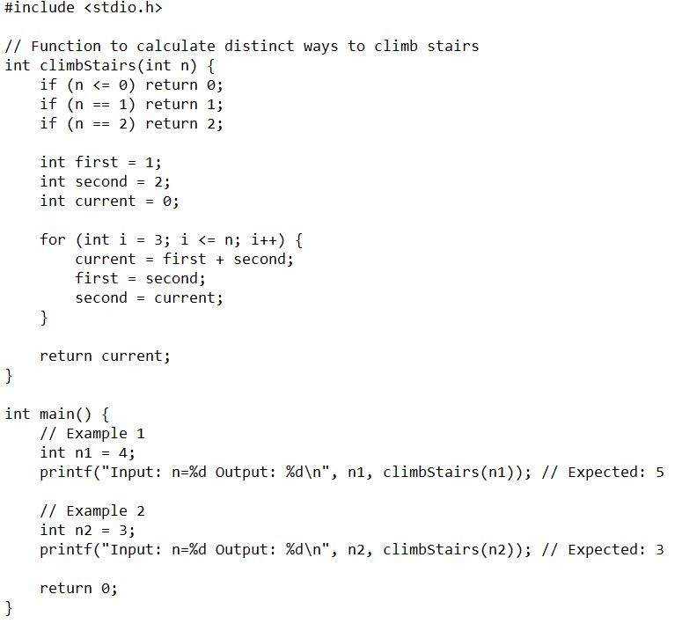
Output:
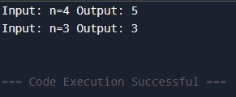
Time Complexity: O(n)
Space Complexity: O(1)

14.
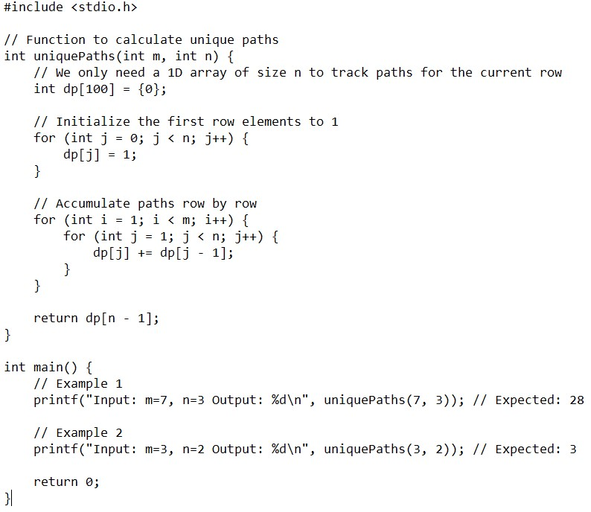
Output:
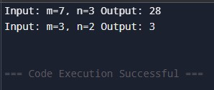
Time Complexity: O(m . n)
Space Complexity: O(n)

15.
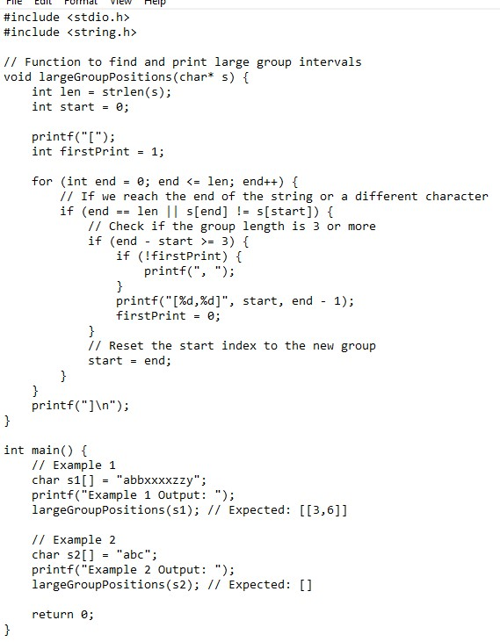
Output:
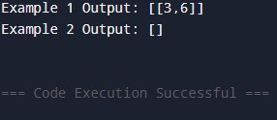
Time Complexity: O(n)
Space Complexity: O(1)

16.
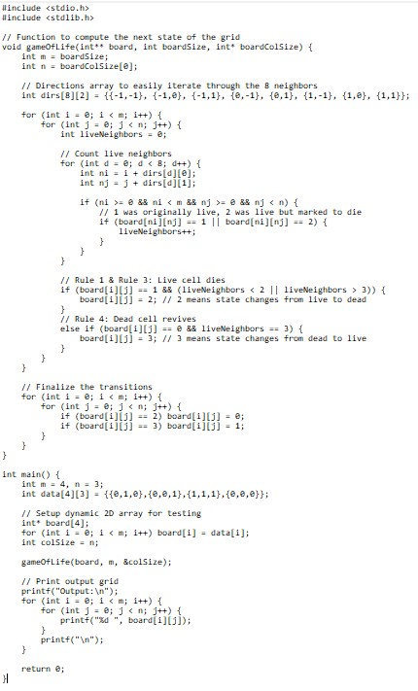
Output:
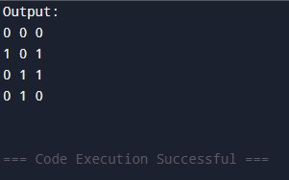
Time Complexity: O(m . n)
Space Complexity: O(1)

17.
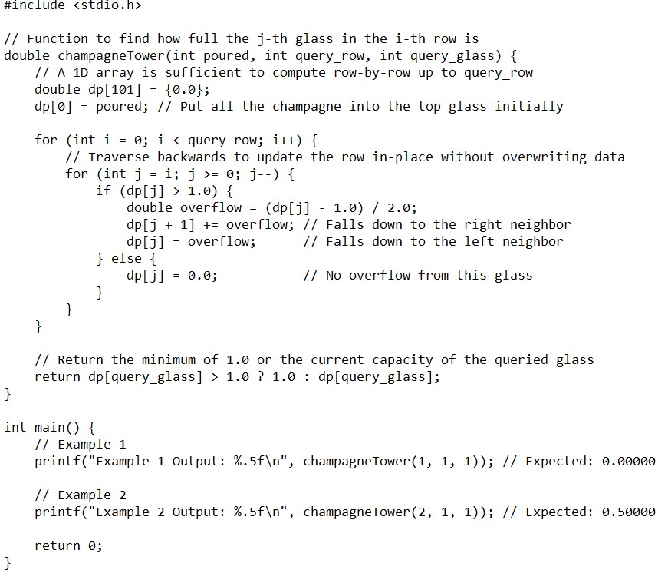
Output:
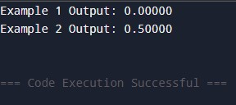
Time Complexity: O(n^2)
Space Complexity: O(n)

